INNOLOFT VENTURES | InnoTrack Daily Report | 20-Day Internship Program

DAILY INTERNSHIP REPORT
Submit this report on InnoTrack by 5:00 PM every day
SECTION 1 — STUDENT INFORMATION

Student Name | Nareddy.Shanmukha Nihal Reddy | VTU ID | 28683
Branch / Dept. | CSE(AI&DS) | Internship Day No. | 3
Date | 03/06/2026 | Track (1 / 2 / 3 / 4) | 1
Project Title | Customer Churn Prediction System - E-commerce | Mentor Name | JAYASRI

SECTION 2 — WHAT DID YOU LEARN TODAY?

Topic / Concept Learned
Learned NumPy arrays and performed statistical operations such as mean, maximum, minimum, standard deviation, and filtering using conditions.
Learned Pandas DataFrames and CSV handling, including loading datasets, exploring data with head(), shape, columns, and checking data types.

Performed Exploratory Data Analysis (EDA) using isnull(), value_counts(), groupby(), mean(), and analyzed the E-commerce Customer Churn dataset to gain business insights.

SECTION 3 — WHAT DID YOU BUILD TODAY?

Code / Output / Feature Built (e.g. Built EDA section, trained model, created Flask form...)
NumPy Marks Analyser:
https://github.com/NSNihalreddy/VELTECH-SUMMER-INTERNSHIP-/blob/main/Innolift%20Ventures/Track%201/DAY%203/exersice%201.py
OUTPUT:
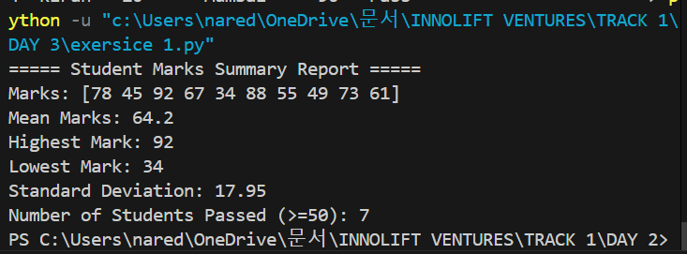
FEATURE BUILT: Developed a NumPy-based student marks analysis system to calculate mean, maximum, minimum, standard deviation, and identify passed students using boolean filtering.
DataFrame Builder:
https://github.com/NSNihalreddy/VELTECH-SUMMER-INTERNSHIP-/blob/main/Innolift%20Ventures/Track%201/DAY%203/exersice%202.py
OUTPUT:
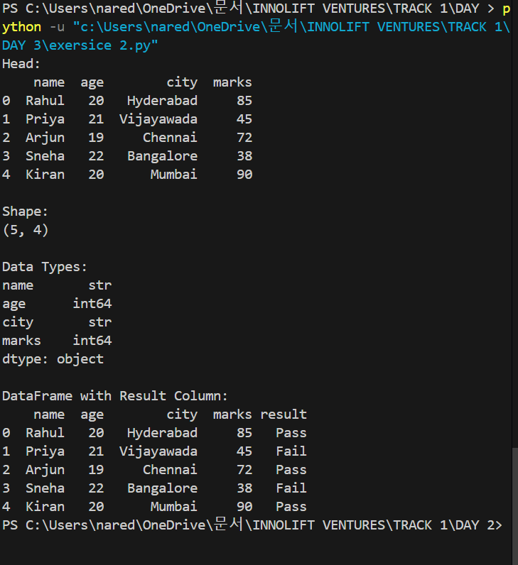
FEATURE BUILT: Built a Pandas DataFrame to manage student records and implemented automatic Pass/Fail result generation based on marks.
CSV Explorer:
https://github.com/NSNihalreddy/VELTECH-SUMMER-INTERNSHIP-/blob/main/Innolift%20Ventures/Track%201/DAY%203/exersice%203.py
OUTPUT:

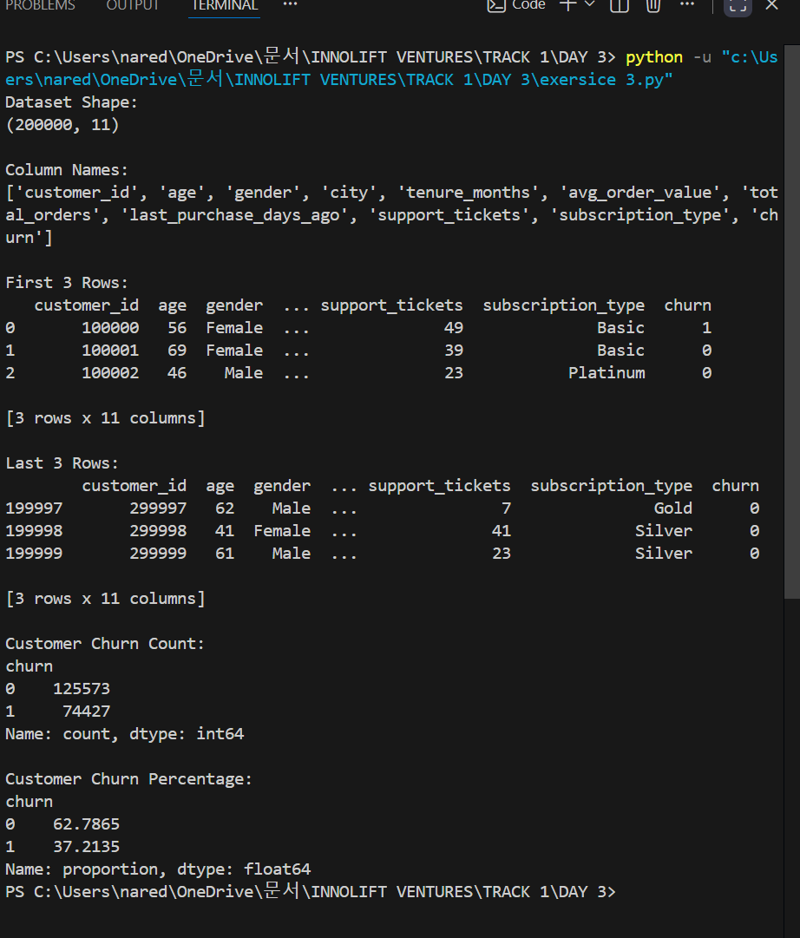
FEATURE BUILT:
Developed a CSV data exploration tool to load datasets, inspect structure, view records, and analyze customer churn distribution using Pandas.
Missing Data Detective:
https://github.com/NSNihalreddy/VELTECH-SUMMER-INTERNSHIP-/blob/main/Innolift%20Ventures/Track%201/DAY%203/exersice%204.py
OUTPUT:
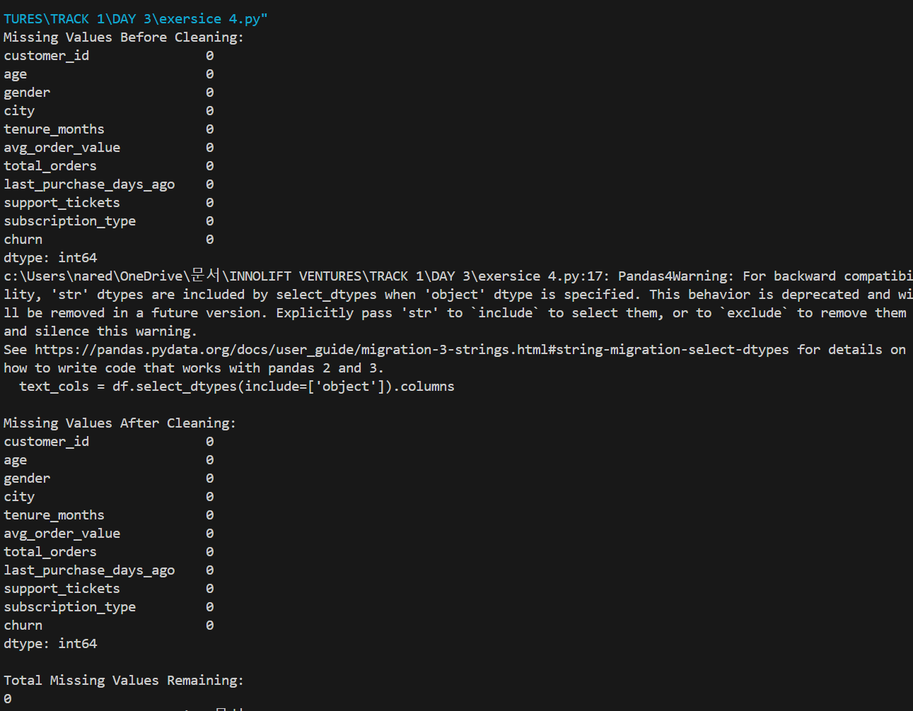
FEATURES BUILT:Developed a data cleaning module to detect missing values, handle null data using mean and default values, and ensure dataset completeness.
Group & Compare:
https://github.com/NSNihalreddy/VELTECH-SUMMER-INTERNSHIP-/blob/main/Innolift%20Ventures/Track%201/DAY%203/exersice%205.py
OUTPUT:
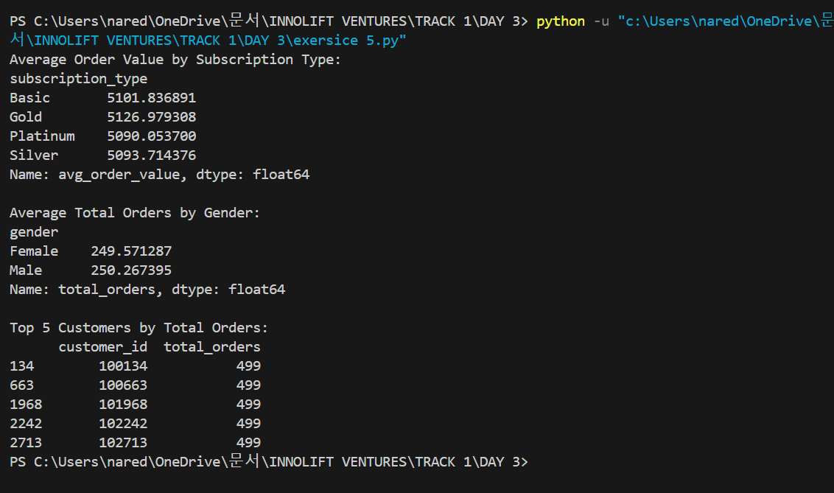
FEATURES BUILT:
Developed a customer segmentation analysis module using groupby() to compare average order values, customer behavior, and identify top-performing customers.
Full EDA Report:
https://github.com/NSNihalreddy/VELTECH-SUMMER-INTERNSHIP-/blob/main/Innolift%20Ventures/Track%201/DAY%203/exersice%206.py
OUTPUT:
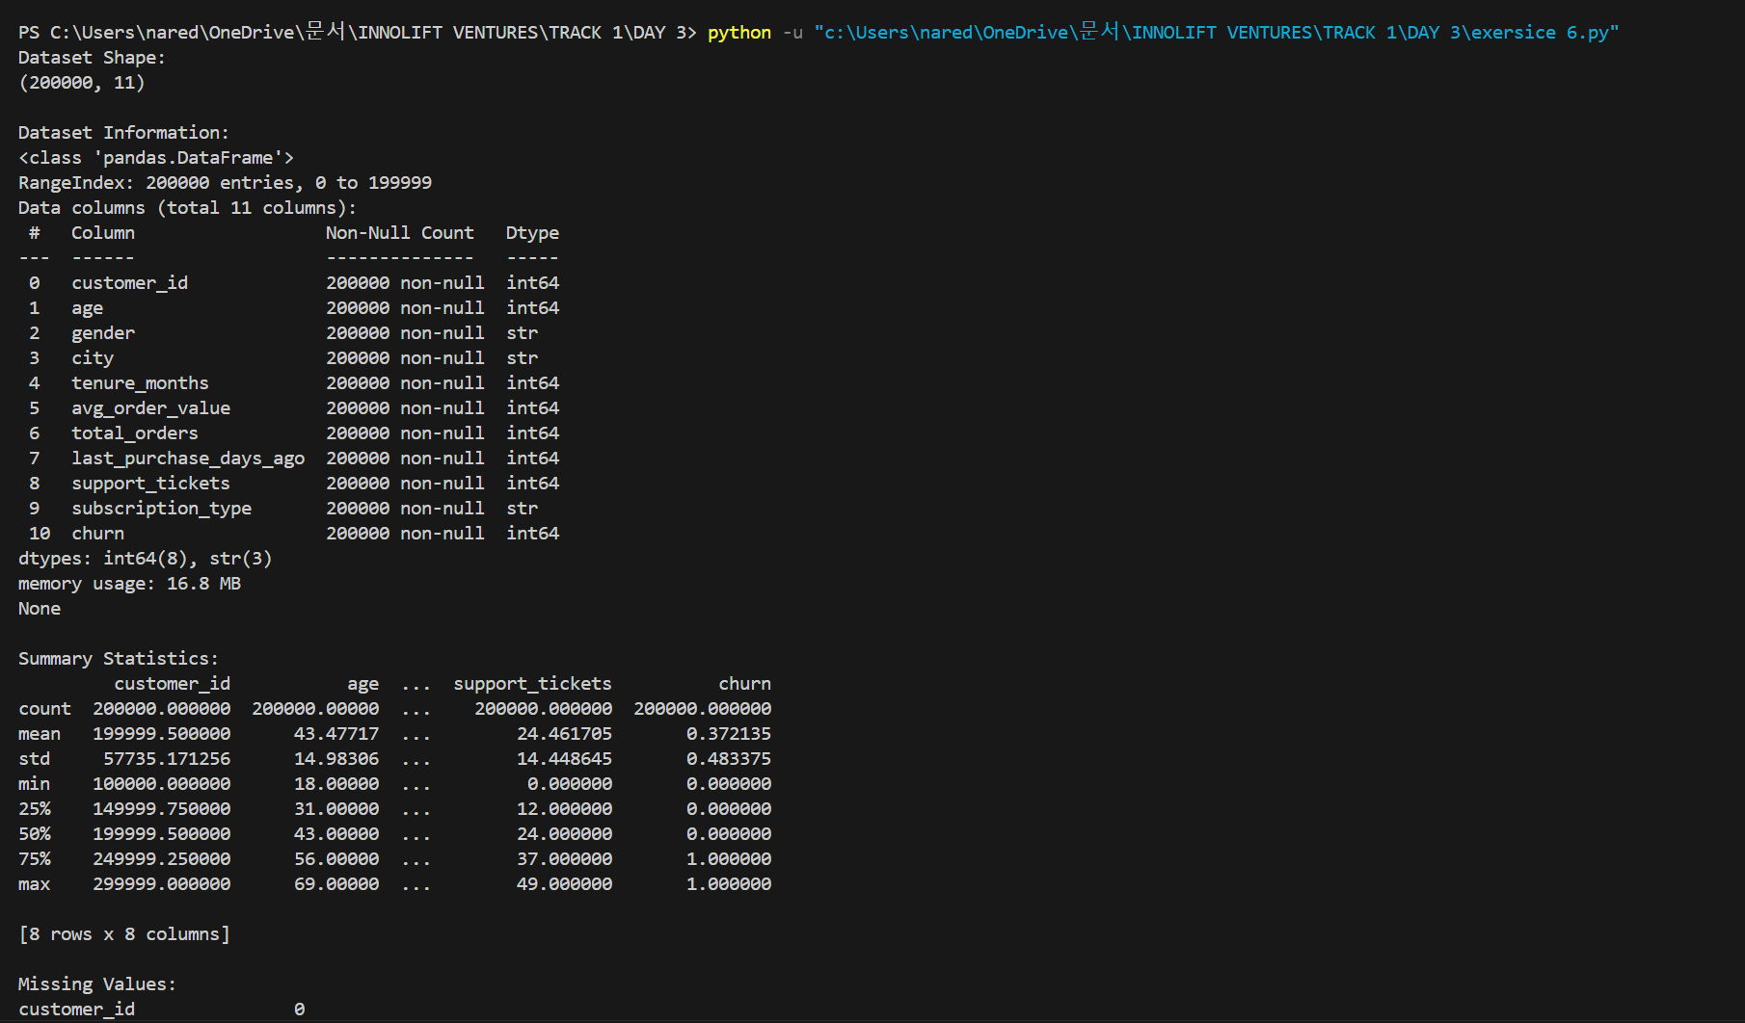
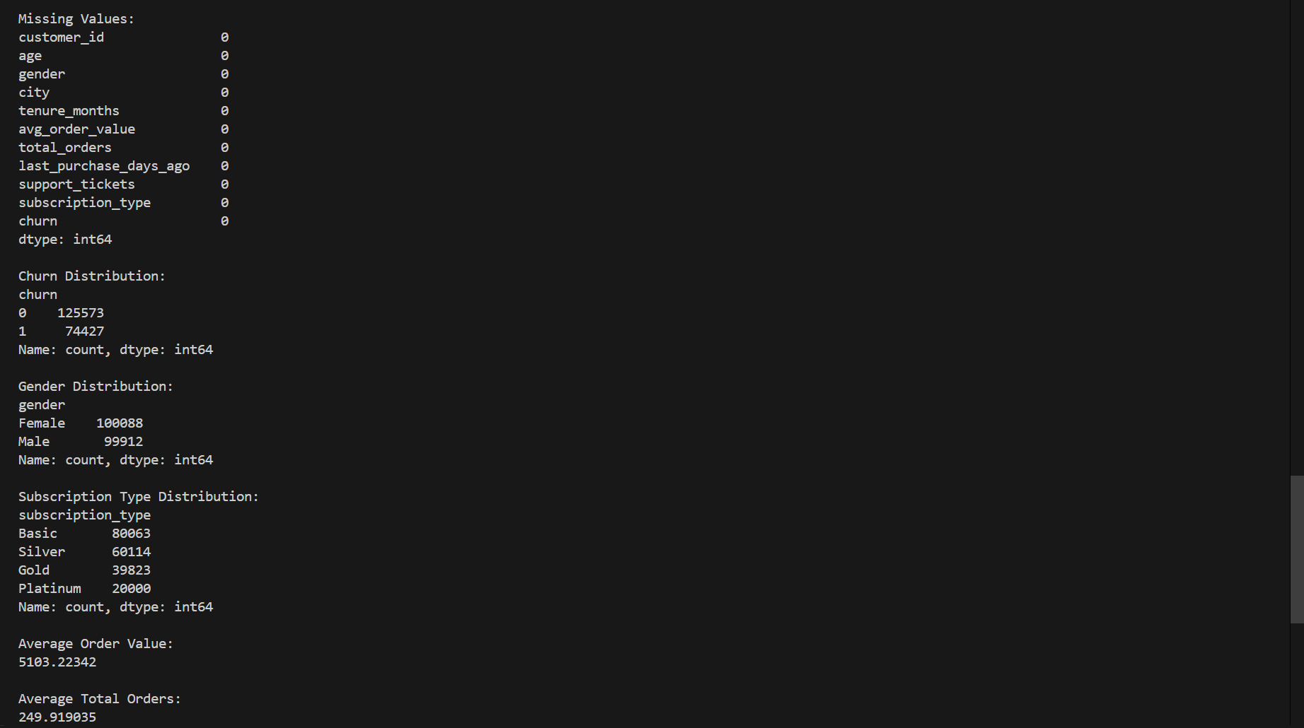
FEATURE BUILT:
Developed an automated Exploratory Data Analysis (EDA) report generator to summarize dataset structure, missing values, statistics, and categorical distributions.

SECTION 4 — PROBLEMS FACED & HOW YOU SOLVED THEM

Error / Problem
Faced package installation issues and difficulties in understanding NumPy and Pandas functions during initial implementation.
Encountered dataset loading errors (FileNotFoundError) and challenges in performing data analysis operations such as grouping, missing value handling, and EDA.
How I Fixed It
Installed the required libraries, referred to documentation, and tested functions with sample data.
Corrected the dataset path, verified file locations, and used appropriate Pandas functions to clean and analyze the dataset successfully.

SECTION 5 — PLAN FOR TOMORROW

What will you do tomorrow?
Learn data visualization using Matplotlib and create different chart types such as line charts, bar charts, histograms, and pie charts.
Build and train the first Machine Learning model using a real dataset and evaluate its performance using basic metrics.

SECTION 6 — LINKS & ATTACHMENTS

GitHub Repo / Commit Link | https://github.com/NSNihalreddy/VELTECH-SUMMER-INTERNSHIP-/tree/main/Innolift%20Ventures/Track%201/DAY%203
Model Result / Colab Link | Successfully performed data analysis and exploratory data analysis (EDA) on the E-commerce Customer Churn dataset, generating insights on customer behavior, churn distribution, and dataset characteristics.
Deployed App Link (if any) | NA
Additional Notes | Gained hands-on experience with NumPy and Pandas for real-world data analysis tasks.  Worked with a large E-commerce Customer Churn dataset and learned the importance of correct dataset paths and data exploration before analysis.  Improved understanding of data cleaning, grouping, and EDA techniques that are essential for Machine Learning projects.  DATASET LINK: https://www.kaggle.com/datasets/kuldeepjangra/e-commerce-customer-churn-dataset-200k-records

SECTION 7 — SELF RATING FOR TODAY

Area | 1 | 2 | 3 | 4 | 5
Understanding of today's concept | ☐ 1 | ☐ 2 | ☐ 3 | ☑ 4 | ☐ 5
Hands-on coding confidence | ☐ 1 | ☐ 2 | ☐ 3 | ☐ 4 | ☑ 5
Progress on my project | ☐ 1 | ☐ 2 | ☐ 3 | ☐ 4 | ☑ 5
Overall satisfaction with today | ☐ 1 | ☐ 2 | ☐ 3 | ☑ 4 | ☐ 5

